- Refer to the following diagram below and identify the parts of the wave indicated.

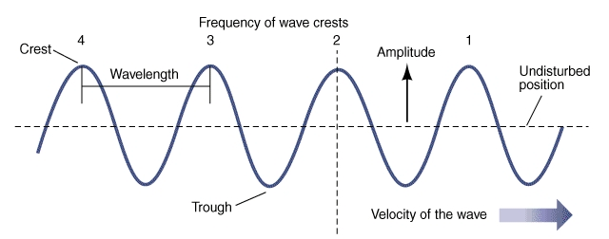
a
b
c
d
e
- Sketch the relationships between frequency and wavelength and frequency vs period on the axes below.
Frequency
Wavelength

- Define two points on the waveform below that are:
    - In phase
    - Out of phase
A
B
C
D
E

- Being an astute physics student, while at the beach on vacation, you notice that the time between each successive wave crashing along the shoreline takes about 8 seconds. You also notice that the distance between the wave crests appears to be about 100 ft (~30 meters) due to a beached vessel a short distance away. Determine the frequency and speed of the waves.

- You are lost in a canyon out west, so you decide to yell for help (no cell service in the middle of nowhere). After you yell, you think that someone else is yelling for help when you hear their call about 3 seconds later. Unfortunately, it is only an echo. Knowing that the speed of sound in air is about 331 m/s, determine how far you are from the walls of the canyon.

- The diagram below represents two wave pulses traveling in opposite directions. Sketch on the diagram the resulting waveform where they meet, and their appearance after they meet.

